Nginx
# Source: Chatgpt (GPT-5-Mini) at [1/16/2026]
Nginx (pronounced "engine-x") is a high-performance, open-source web server, reverse proxy server, and load balancer. It was originally developed by Igor Sysoev in 2004 to address the C10k problem—handling 10,000 concurrent connections efficiently.

🔧 What Nginx Can Do:
# Source: Chatgpt (GPT-5-Mini) at [1/16/2026]
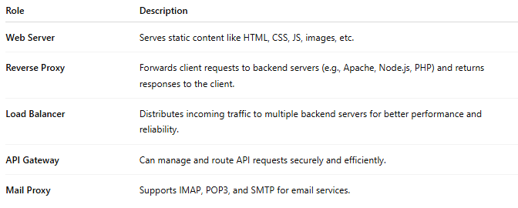
Role | Description
Web Server | Serves static content like HTML, CSS, JS, images, etc.
Reverse Proxy | Forwards client requests to backend servers (e.g., Apache, Node.js, PHP) and returns responses to the client.
Load Balancer | Distributes incoming traffic to multiple backend servers for better performance and reliability.
API Gateway | Can manage and route API requests securely and efficiently.
Mail Proxy | Supports IMAP, POP3, and SMTP for email services.

⚙️ Key Features
# Source: Chatgpt (GPT-5-Mini) at [1/16/2026]
- Asynchronous & Event-driven architecture — very lightweight and efficient.
- Fast Static Content Delivery — ideal for serving images, videos, and files.
- SSL/TLS Support — can handle HTTPS with certificate management.
- URL Rewriting & Redirection — using regular expressions.
- Rate Limiting, Caching, Compression — for traffic control and performance.
- Modular Configuration — configuration via a simple text-based file (nginx.conf).

📌 Common Use Cases
# Source: Chatgpt (GPT-5-Mini) at [1/16/2026]
- Hosting static websites.
- Acting as a reverse proxy in front of backend apps like Node.js, Python (Django, Flask), Ruby on Rails.
- Load balancing between multiple web servers.
- Securing and managing APIs.
- Running Dockerized web apps with containers.

🔄 Nginx vs Apache
# Source: Chatgpt (GPT-5-Mini) at [1/16/2026]
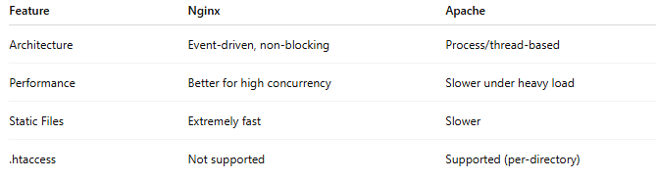
Feature | Nginx | Apache
Architecture | Event-driven, non-blocking | Process/thread-based
Performance | Better for high concurrency | Slower under heavy load
Static Files | Extremely fast | Slower
.htaccess | Not supported | Supported (per-directory)

📁 Configuration Example
# Source: Chatgpt (GPT-5-Mini) at [1/16/2026]
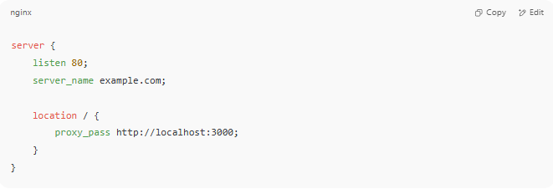
server {
listen 80;
server_name example.com;

location / {
proxy_pass http://localhost:3000;
}
}

This config acts as a reverse proxy, forwarding traffic from port 80 to a backend app on port 3000.

